TCN4211
Telecommunication Networks

Lab Number 7
Title VPN configuration lab using routers in cisco packet tracer

Author Name: Anaisy Garcia PID: 5734454

Oct 18



Florida International University

OBJECTIVES:
The objectives of this lab are to learn how to configure and use VPNs on routers and learn to create VPN tunnels between routers.

EQUIPMENT and COMPONENTS USED
For this lab the equipment used was:
- Laptop
- Cisco Packet Tracer Program
Within the Cisco Program, the components used were three routers, and two generic PCs.

EXPERIMENTAL METHOD AND PROCEDURE
- Build the topology of three routers and two PCs.
- Assign IP address on each interface of the routers and assign IP addresses to the computers.
- All networks are:
  - network 192.168.1.0/24
  - network 192.168.2.0/24
  - network 1.0.0.0/8
  - network 2.0.0.0/8
- Configure router1 using:
  - Router>enable
  - Router#config t
  - Router(config)#host r1
  - r1(config)#int fa0/0
  - r1(config-if)#ip add 192.168.1.1 255.255.255.0
  - r1(config-if)#no shut
  - r1(config-if)#exit
  - r1(config)#int fa0/1
  - r1(config-if)#ip address 1.0.0.1 255.0.0.0
  - r1(config-if)#no shut
- Configure router2 using:
  - Router>enable
  - Router#config t
  - Router(config)#host r2
  - r2(config)#int fa0/0
  - r2(config-if)#ip add 1.0.0.2 255.0.0.0
  - r2(config-if)#no shut
  - r2(config-if)#exit
  - r2(config)#int fa0/1
  - r2(config-if)#ip add 2.0.0.1 255.0.0.0
  - r2(config-if)#no shut
- Configure router3 using:
  - Router>enable
  - Router#config t
  - Router(config)#host r3
  - r3(config)#int fa0/0
  - r3(config-if)#ip add 2.0.0.2 255.0.0.0
  - r3(config-if)#no shut
  - r3(config-if)#exit
  - r3(config)#int fa0/1
  - r3(config-if)#ip add 192.168.2.1 255.255.255.0
  - r3(config-if)#no shut
- Configure default routing on router1:
  - r1>enable
  - r1#config t
  - Enter configuration commands, one per line. End with CNTL/Z.
  - r1(config)#ip route 0.0.0.0 0.0.0.0 1.0.0.2
- Configure default routing on router3:
  - r3>enable
  - r3#config t
  - Enter configuration commands, one per line. End with CNTL/Z.
  - r3(config)#ip route 0.0.0.0 0.0.0.0 2.0.0.1
- Ping each router to check for successful connection.
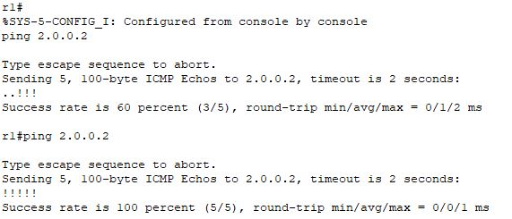
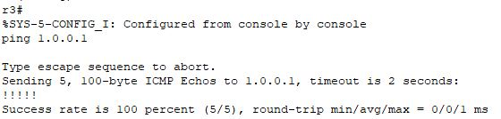
- Create a VPN tunnel between router1 and router3.
- Configure a VPN tunnel on router1:
  - r1#config t
  - r1(config)#interface tunnel 10
  - r1(config-if)#ip address 172.16.1.1 255.255.0.0
  - r1(config-if)#tunnel source fa0/1
  - r1(config-if)#tunnel destination 2.0.0.2
  - r1(config-if)#no shut
- Configure a VPN tunnel on router3:
  - r3#config t
  - r3(config)#interface tunnel 100
  - r3(config-if)#ip address 172.16.1.2 255.255.0.0
  - r3(config-if)#tunnel source fa0/0
  - r3(config-if)#tunnel destination 1.0.0.1
  - r3(config-if)#no shut
- Ping each router to check for successful connection again.
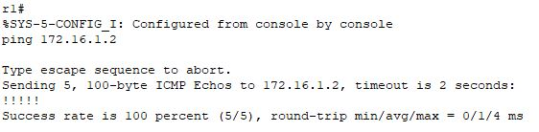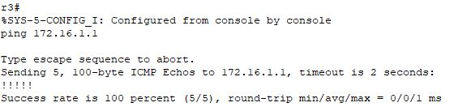
- Route for created VPN tunnel on router1 and router 3:
  - r1(config)#ip route 192.168.2.0 255.255.255.0 172.16.1.2
  - r3(config)#ip route 192.168.1.0 255.255.255.0 172.16.1.1
- Test if tunnel was created:
  - r1#show interfaces Tunnel 10
  - r3#show interface Tunnel 100
- To trace the path ping PC1 from PC0 then use tracert.
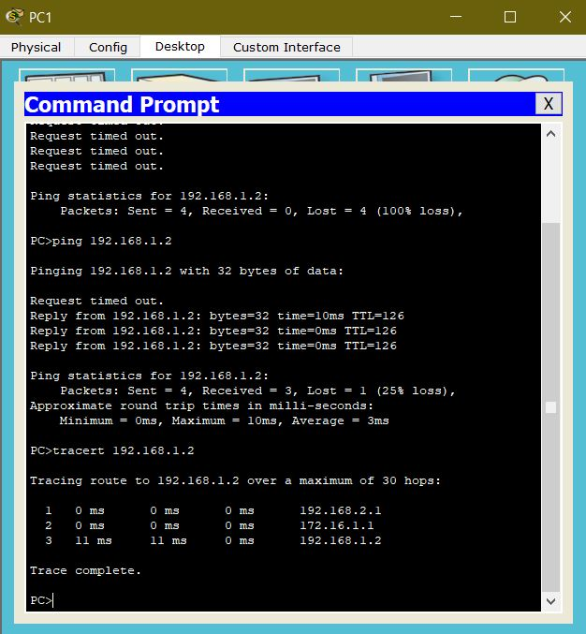
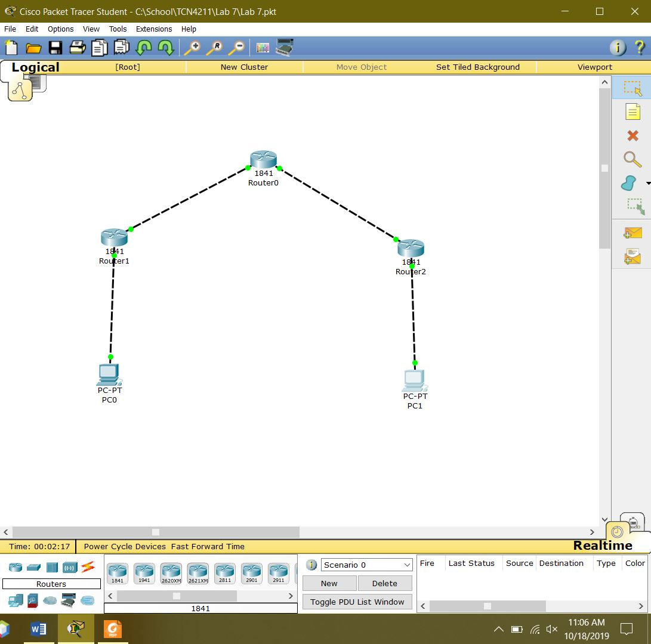
RECOMMENDATIONS and CONCLUSIONS
This lab consisted of understanding how to set up and configure VPNs at router level rather than at PC level from previous labs. In this lab a VPN tunnel had to be created to act as a shortcut between two routers. This practice helps reduce the time a packet would take to travel due to it skipping over the third router connecting the bottom two. This can be useful in the real world for communicating over large networks.

